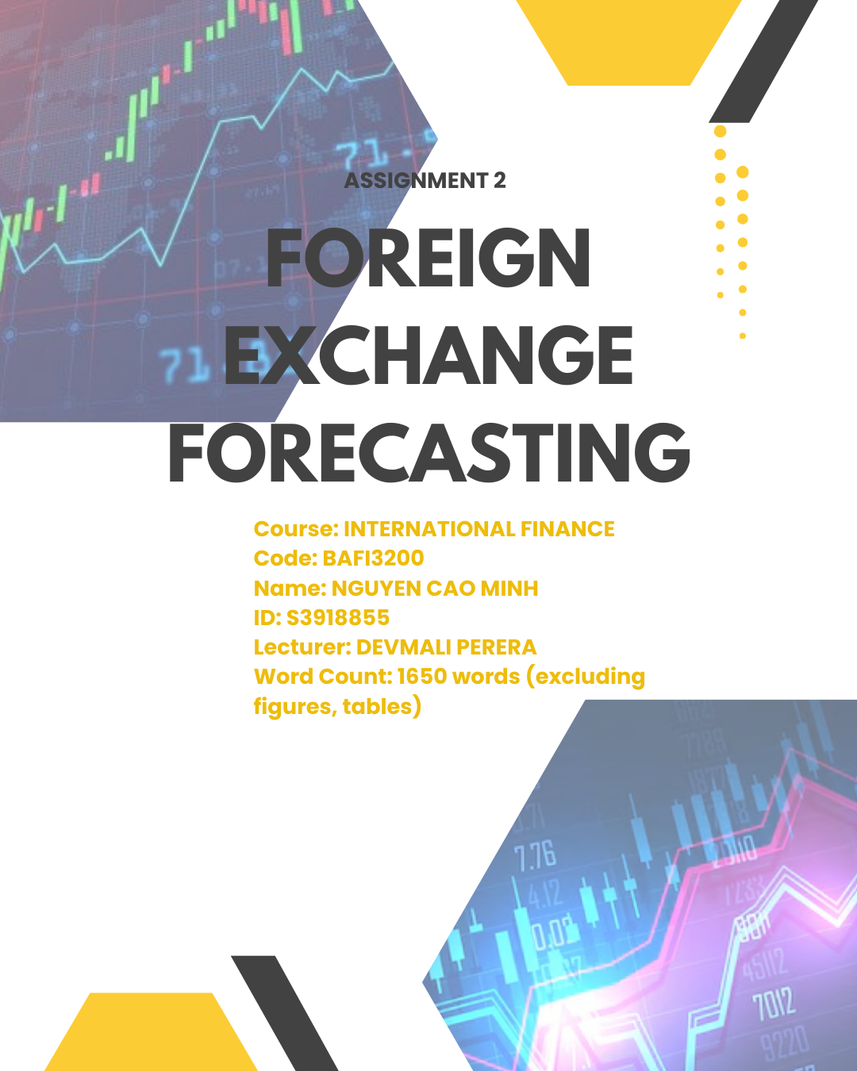

|  |  |
| --- | --- |
| **ABBREVIATION** | |
| CABdiff | Lagged current account balance differential |
| COMch | Primary commodity price change |
| ER | Exchange rate |
| EUM2ch | M2 changes of EU area |
| EUSTOCKch | EU Stoxx 50 change |
| GFE | Generalized Fisher Effect |
| IFE | International Fisher Effect |
| INFLATIONdiff | Lagged inflation differential |
| IR | Interest rate |
| IRP | Interest rate parity |
| LTIRdiff | Lagged long-term interest rate differential |
| OILch | Oil price change |
| STIRdiff | Lagged short-term interest rate differential |
| VNM2ch | M2 changes of Vietnam |
| VNSTOCKch | VN-index change |

**Table of Contents**

**QUESTION 1** 4

**I.** **BACKTESTING** 4

**1.** **IFE-model** 4

**2.** **Macro-model** 6

**a)** **Literature review** 6

**b)** **Independent variable** 6

**c)** **Model construction** 8

**d)** **Hypothesis testing & Interpretation** 10

**II.** **Forecasting** 13

**1.** **IFE-model** 13

**2.** **Macro-model** 14

**3.** **Comparison** 15

**4.** **Mixed-model** 16

**QUESTION 2** 18

**QUESTION 3** 21

**I.** **BOP** 21

**II.** **SDG** 25

**APPENDIX** 28

**REFERENCE** 33

# **QUESTION 1**

## **BACKTESTING**

### **IFE-model**

#### **Reason**

Amid controversy, Itskhoki (2020) experienced deviation from PPP theory due to different goods and services baskets, and trade barriers among countries. Moreover, PPP-defined equilibrium is deviated with challenges to construct identical goods basket each region with income, natural resources, culture and labor productivity difference, causing pricing and elasticity distinction(Glantz et al. 2014). Besides, IRP focuses solely IR differentials for ER movement explanation, lacking risk factors, including financial disruptions, political instability and investor sentiment(Cetin 2020). Moreover, perfect capital mobility without transaction costs assumptions is unrealistic with regulations, market conditions, and controls, which offset arbitrage gain with low-to-high IR (Sumei and Guangyou 2016). Hence, investors lack motivation to exploit discrepancies that contest UIP validity (Rodrik 2008). For accuracy effectiveness, IFE-model is applied for both inflation and IR considerations.

#### **Theoretical review**

IFE-model combines GFE and PPP characteristics(Adam and Ofori 2017). While GFE stated positive relationship between nominal IR and expected inflation with constant real IR and capital outflow prevention, PPP is incorporated for witnessing relatively-high expected inflation cause depreciation. From IFE, for offsetting expected inflation, currency with higher nominal IR, incurs depreciation.

#### **Model construction**

IFE-model is constructed with quarterly data from Q1/2007 to Q3/2023 in EUR/VND spot rate and IR of Euro Area and Vietnam(66 observations). IFE-model analyzes impact of one-quarter lagged IR differentials on EUR/VND change. This lagged approach effectively diminishes autocorrelation and clarifies causal connection between inflation and ER movement, improving accuracy(Keele and Kelly 2005).

|  |  |
| --- | --- |
| **Equation** |  |
|  | EUR/VND spot rate change from time t to t-1 (%) |
|  | Lagged interest rate differential at time t-1 (%) |
|  | VN interest rate |
|  | EU interest rate |

***Table 1****: IFE model equation*

#### **Hypothesis testing & Interpretation**

|  |  |  |
| --- | --- | --- |
|  | **Symbols** | **Interpretation** |
| **Null hypothesis** |  | Lagged interest rate differential is statistically insignificant to ER |
| **Alternative hypothesis** |  | Lagged interest rate differential is statistically significant to ER |
| **P-value** | 0.138 > 0.1 > 0.05 | With values higher than both 0.05 and 0.1 significance level, ís not rejected |
| **Adjusted** | 0.019 | Lagged interest rate differential only explain 1.9% EUR/VND movement, while the remaining is from other omitted variables. |
| **Coefficient** |  | Because of insignificance, coefficient should not be interpreted. However, in case of significance, it is stated that for every 1% increase in lagged interest rate differential, EUR/VND change decreases by 0.36%, |
| **Intercept** | 0.027 | If lagged interest rate differential is 0, EUR/VND change is 0.027% |
| **Conclusion** | Lagged interest rate differential has no statistical relationship with EUR/VND fluctuation, which is inconsistent with IFE theory. To conclude, IFE model is not suitable for forecasting with poor explanatory of independent variable. | |

***Table 2****: Hypothesis testing results and interpretation of IFE model*

### **Macro-model**

### **Literature review**

Devereux (1997) proposed SPMM model for capturing macro-economic effects on ER movement, shown in research of Antwi et al.(2020), and Jamil et al.(2023). Lagged macroeconomic variables were incorporated into SPMM for experiencing nuanced and time-sensitive nature of macro-variables' impacts on ER, applied in Macro-model.

### **Independent variable**

Data sources is in **Appendix 1**

|  |  |  |
| --- | --- | --- |
| **Variable** | **Expected relationship** | **Literature review** |
| **GDPdiff** |  | Rodrik (2008)’s analysis in EU countries state that higher economic growth rate country is expected to bring appreciation when attracting capital inflows; however the effect is not straightforward. Besides, the positive relationship between growth differentials and exchange rate is explained by interest rate hike expectation by (Anzuini et al. 2016). |
| **INFLATIONdiff** |  | Koprnická found currency appreciation association with narrowed inflation gap (Koprnická 2009). Furthermore, higher inflation makes currency weaker due to expensive export and cheap imports (Edward 2006), specifically confirmed through analysis in Asean+3, and the EU (Umar and Dahalan 2016). However, Moore and Wang (2014) state that the relationship is even stronger in high-inflation countries. |
| **CABdiff** |  | The research by EU-15 countries confirms export increase brings more demand for EU in short term (Bogdan et al. 2017). In long-term, when CAB difference starts decreasing, it is sign of excessive appreciation, which overprice export; then currency start depreciating through analysis in both EU and Asia (Arghyrou & Chortareas 2008) (Phan and Jeong 2015). Hence, if CAB of Vietnam is higher, it signs VND attractive, however, it may be opposit in long-term when currency rise with price level, causing expensive export. |
| **STOCKEUch** |  | Evidently, the research in Asian region against EUR witnessed blooming stock market attracts investors capital flows from domestic and foreign with sign of asset price rise; thus, increasing local currency demand since investor wealth and demand's relying on stock performance with investment climate sensitivity (Pan et al. 2007) |
| **STOCKVNch** |  |
| **OILch** |  | Zizkov et al. (2019) discovered negative relationship between oil price and exchange rate in Asian countries, mainly oil-importers. Since critical non-renewable energy, oil price affects global economy (Vochozka 2020). Although most Euro countries are oil-importers, it still has some exporters with less response to oil shock while that of Vietnam is significant; therefore, oil price increase is expected to make EUR/VND appreciation despite ER and oil price negative nexus. Besides, commodity price experienced similar connection. |
| **COMch** |  |
| **EUM2ch** |  | Money supply has inverse relationship to exchange rate since MS rise alongside with interest rate drop, posing expected inflation, which cause depreciation. Hence, as money supply of EUR increases faster than VND, EUR is expected depreciated (Ali et al. 2015). It is analyzed by Dang et al. (2020) in Vietnamese market. |
| **VNM2ch** |  |
| **STIR and LTIR diff** |  | Rise in the exchange rate corresponds to increase in interest rates that larger lagged interest rate differential makes EUR/VND appreciated according to IFE theory. |

***Table 3****: Independent variables explanation in Macro Model*

### **Model construction**

Variables are collected similar to IFE-model’s. Before analysis, multicollinearity and heteroskedasticity must be ensured BLUE OLS-estimators for precise.

|  |  |  |
| --- | --- | --- |
| **Correlation Coefficient** | **VIF** | |
|  | **Variable** | **VIF value** |
| Differential STIR | 2.457442 |
| Differential LTIR | 3.669252 |
| Differential Inflation | 2.847977 |
| Differential GDPGR | 1.100175 |
| Differential CAB | 1.256245 |
| Change in oil price | 1.631738 |
| Change in commodity price | 1.139487 |
| Change in EUR's stock | 2.107945 |
| Change in VND's stock | 1.701664 |
| Change in EUR's M2 | 1.278057 |
| Change in VND's M2 | 1.248684 |

***Table 4****: Multicollinearity check by Correlation Coefficient and VIF*

|  |  |  |
| --- | --- | --- |
|  | **Symbols** | **Interpretation** |
| **Null hypothesis** |  | Model is homoskedasticity |
| **Alternative hypothesis** |  | Model is heteroskedasticity |
| **P-value** |  | is not rejected that Model has no heteroskedasticity |

***Table 5****: Heteroskedasticity check by White test*

Coefficient witnesses relatively small r between independent variables, except **LTIRdiff&STIRdiff**, and **LTIRdiff&INFdiff** along all lower-than-10 VIF value but highest in **LTIRdiff(Appendix 2,3)**. Consequently, dropping alternatives are implemented with **LTIR** to diminish multicollinearity (Wooldridge 2009). Besides, there is no heteroskedasticity with White-test. Then, equation is:

### **Hypothesis testing & Interpretation**

* **F-test**

|  |  |  |
| --- | --- | --- |
|  | **Symbols** | **Interpretation** |
| **Null hypothesis** |  | All explanatory variable jointly have no impact on EUR/VND change |
| **Alternative hypothesis** |  | At least one explainatory variable have impact on EUR/VND change |
| **Independent variable** |  | GDPdiff, INFdiff, STIRdiff, OILch, COMch EUSTOCKch, VNSTOCKch, EUM2ch, VNM2ch, CABdiff |
| **Significance F** |  | **There is at least one independent variable affecting EUR/VND change at 10% significance level**, but variables jointy have no impact in 5% level. |

***Table 6****: F-test result and interpretation*

* **P-value approach**

|  |  |  |
| --- | --- | --- |
|  | **Symbols** | **Interpretation** |
| **Null hypothesis** |  | Independent variable is statistically insignificant to EUR/VND change |
| **Alternative hypothesis** |  | Independent variable is statistically significant to EUR/VND change |

***Table 7****: P-test approach*

|  |  |  |  |  |  |
| --- | --- | --- | --- | --- | --- |
| **R-squared** | **Adjusted R-squared** | **Variable** | **P(>|t|)** | **Comparison with significant level** | **Evaluation** |
| 0.2464 | 0.1094 | **GDPdiff** | 0.582 |  | Non-rejecting |
| **VNSTOCKch** | 0.164 |
| **INFLATIONdiff** | 0.331 |
| **OILch** | 0.200 |
| **COMch** | 0.512 |
| **CABdiff** | 0.140 |
| **EUSTOCKch** | 0.776 |
| **EUM2ch** | 0.063 |  | Rejecting at 10% significance level |
| **STIRdiff** | 0.0397 | < 0.05 | Rejecting at 5% significance level |
| **VNM2ch** | 0.0414 |

***Table 8****: P-test result and interpretation*

There are three statistically-significant variables, including EUM2ch, STIRdiff, and VNM2ch at 10% level, while STIRdiff and VNM2ch are also significant at 5% level. Besides, R-squared shows 24.64% explanation of EUR/VND change, higher than 10.94% in adjusted R-squared, showing consequences of insignificant variables' addition. Thus, Macro-model actually represents 10.94% of EUR/VND change with remainings from unobserved variables.

|  |  |  |
| --- | --- | --- |
| **Slope estimates** | **Relationship** | **Interpretation** |
|  | Negative | For every 1% increase in EUM2, EUR/VND change decrease by 1.431%, ceteris parabus |
|  | Negative | For every 1% increase in STIR differentials, EUR/VND change decrease by 0.6430 %, ceteris parabus |
|  | Positive | For every 1% increase in EUM2, EUR/VND change increase by 0.4413 %, ceteris parabus |

***Table 9****: Coefficients interpretation*

While EUM2ch and VNM2ch witness relationship fitting to expectation from literature review, STIRdiff coefficient is different from IFE with unrealistic assumptions. Furthermore, developed market like EU, have higher real IR than developing one, Vietnam, not fitting assumption (Khawaga et al. 2014). Besides, with significance, Macro-model is more reasonable for forecasting.

## **Forecasting**

## **IFE-model**

|  |  |  |  |  |
| --- | --- | --- | --- | --- |
| **Actual** | **Predicted** | **Absolute Forecast Error** | **Absolute Squared Error** | **Forecast Error** |
| 25664 | 25664 | 1.78% | 0.00032 | (0.01779) |
| 26,773 | 26,297 | 2.52% | 0.00064 | 0.02524 |
| 26,773 | 27,448 | 0.68% | 0.00005 | 0.00680 |

***Table 10****: IFE model forecasting results*

***Figure 1****: Actual vs Predicted values from IFE model*

Overall, prediction and actual shows upward trend; however, different in direction each stage. From Q3/2023 to Q4/2023, appreciation was underestimated by 2,466%, compared to 4,322%. Furthermore, two adjacent stages then record opposite movement; however, error gap is quite small, between 0.68% to 2.52%.

Limitation come from unrealistic IFE assumptions when only considering IR, not capturing remaining 98.1% effect from other variables, including macroeconomic ones since ER dependence on GDP component (Lafrance and Schembri 2002). Moreover, ER is sensitive economic shocks, specifically in 3 forecasted quarters, EU is under inflationary pressure from Russia's invasion, pressing EUR (ECB 2024). Moreover, FED pegs IR at high level, changing global investment flow, leading to high global IR, affecting ER. Without those factors consideration and unrealistic assumption of perfect inflation expectation, model is inaccurate with behavioral bias.

## **Macro-model**

|  |  |  |  |  |
| --- | --- | --- | --- | --- |
| **Actual** | **Predicted** | **Absolute Forecast Error** | **Absolute Squared Error** | **Forecast Error** |
| 26,773 | 27,329 | 0.0208 | 0.0004 | 0.0208 |
| 26,773 | 27,616 | 0.0315 | 0.0010 | 0.0315 |
| 27,261 | 27,854 | 0.0217 | 0.0005 | 0.0217 |

***Table 11****: Macro model forecasting results*

***Figure 2****: Actual vs Predicted values from Macro model*

Forecasted value from Macro-model witnesses similar rising trend of EUR/VND, however, degree of changes is different. While the actual rise 4.3224% in Q4/2023, the predicted overestimated by 6.4882%. Error-gap becomes larger despite similar trend with insignificant variables addition and omitting potential significant ones about investment, political risk index, falling in remaining 89.6%.

## **Comparison**

|  |  |  |  |  |
| --- | --- | --- | --- | --- |
| **Criteria** | **Macro** | **Comparison** | | **IFE** |
| Adjusted R-squared | 10.94% | > | | 1.9% |
| Hypothesis testing | Significant | | Insignificant | |
| MAE | 0.0174 | < | | 0.0364 |
| MSE | 0.0006 | < | | 0.0023 |
| Root MSE | 0.0240 | < | | 0.0478 |

***Table 12****: IFE and Macro models comparison*

Overall, both models do not show majority of EUR/VND change. However, Macro-model with three significant factors, explains better with higher adjusted R-squared. Furthermore, accuracy degree is considered through three principal predictive error indicators, including MAE, MSE, and Root-MSE. Obviously, all Macro model’s values are lower, showing smaller mean variation between real and forecasted data. Thus, Macro-model is better and chosen for forecasting despite both models’ backward-looking weakness with historical dependence.

## **Mixed-model**

Combination methods aggregate multiple forecasting models to improve predictive accuracy(Clemen 1989) since individual employ distinct methodologies and variables. Consequently, CM capitalizes various models’ strengths with comprehensive perspective(Armstrong 2001). Inverse MSE is utilized to determine optimal weights for combining models, favored with effectiveness; being Mixed-model formation base (Clemen and Winkler 1986):

|  |  |  |  |
| --- | --- | --- | --- |
| **Model** | **MSE** | **1/MSE** | **Weight** |
| IFE | 0.0023 | 436.9552 | 20.16% |
| Macro | 0.0006 | 1730.9035 | 79.84% |

***Table 13****: Mixed models formation*

***Figure 3****: Actual vs Predicted values from Mixed model*

|  |  |  |  |  |  |
| --- | --- | --- | --- | --- | --- |
| **Error** | **Mixed** | **Comparison** | **Macro** | **Comparison** | **IFE** |
| MAE | 0.012798 | < | 0.0174 | < | 0.0364 |
| MSE | 0.000287 | < | 0.0006 | < | 0.0023 |
| Root MSE | 0.016938 | < | 0.0240 | < | 0.0478 |

***Table 14****: Three models comparison*

Mixed-model formation is Macro-model biased with nearly-similar Macro-model trend. Gap with actual value is narrowed; however still having errors, obviously in Q1/2024, forecasted one is 1.7% appreciation, when actual one depreciated. Among three models, all error index in Mixed-model are smallest, providing most accuracy, suitable for forecasting.

# **QUESTION 2**

My assigned pair is EUR/VND, however, its condition is insufficient for analyze with short time requirement that 15-minute, 5-hour, one day grapha have extremely-limited candles due to limited transaction. I asked my lecturer for solution, recommended to choose another currency pair from assigned one. With EUR/VND and USA allocation, candlestick analysis is on EUR/USD(Appendix 4,5).

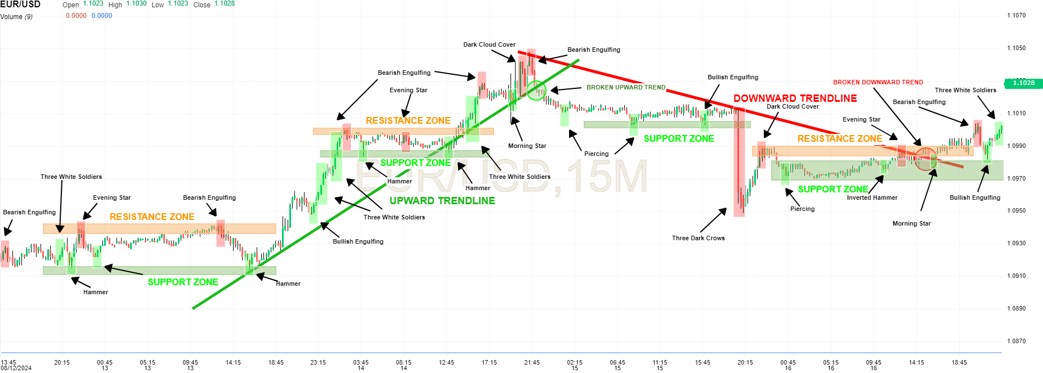

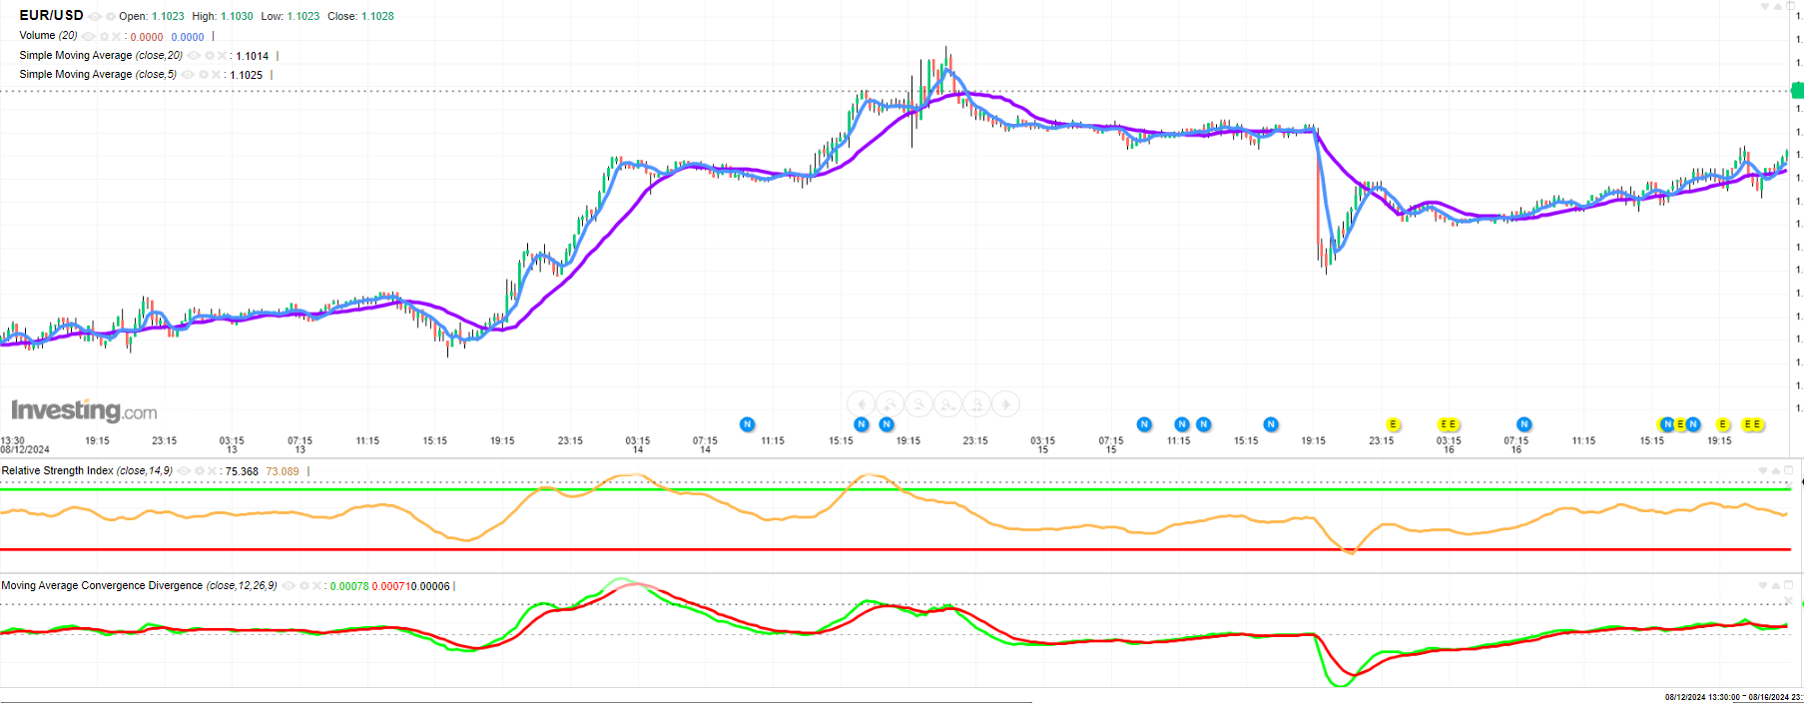***Figure 4****: Candlestick analysis on EUR/USD in 5 days from 12/8/24*

***Figure 5****: MA-5, MA-10 and RSI analysis in 5 days from 12/8/24*

Candlestick charts are conducted to capture trading behavior combined with effective MA-5, MA-10, and RSI for short-term buying-or-selling signals in 4 days(Udagawa 2019)(Bigalow 2011). Besides, 15-minutes chart is applied with accurate support and resistance zone implications(Capra 2012).

In early stages, ER is struggling at 1.0910-1.0940 zone with short-term adjustments from hammer and bearish-engulfing. Despite three-white-soldier appearance, clear bullish not yet appeared, as RSI located in center and almost-fit pattern of two MAs. However, after breaking through resistance at 18:45 on 13th, EUR appreciated with 2 three-white-soldiers and bullish-engulfing with MA-5 cutting MA-20 from bottom, showing updated upward trend. Besides, RSI exceeded 50, reflecting outweighed recent gains, and buy signal. Then, bearish-engulfing appeared early on 14th when RSI exceeded 70, showing overbought and selling signal.

Then, EUR/USD witnessed fluctuations with support zone 1.0990 and not yet surpassed resistance at1.1000. By 17:00, with hammer, showing potential reversal, EUR continued to increase strongly against USD with three-white-soldiers and cross from bottom in MA-5 to MA-20 again. After that, bearish-engulfing appeared again with morning-star, and dark-cloud-cover, showing slowing down signs and officially reversing around 22:00 with bearish-engulfing and cross-from-top MA5 to MA-20 with selling recommendation. After stability, late on 15th witnessed three-dark-crows, interpreted that sentiment changed to bearish; then MA-5 slumps with oversold signal from RSI. Final phase saw gradual EUR recovery; however still stagnant with evening-star and dark-cloud. Then, EUR/USD surpassed resistance level at 1.0990 and signaled three-white-soldiers again with promising EUR appreciation, considered for strategies with observed change level and elasticity with candlestick signal.

Despite overcoming resistance level, 1.0990, it just touched threshold at 19:30. In continuous-exceeding threshold case, buying-recommendation is at 1.100, higher than the19:30 with 12-hours holding, upward trend time in two historical-increasing periods in 18:00 on the 13th and end of 15th. Take-profit and stop-loss price is 1.1050 and 1.0950, previous peak and bottom with three-dark-crows.

# **QUESTION 3**

## **BOP**

***Figure 6****: USD/CNY exchange rate during 2001-2023 (Investing 2024)*

***Figure 7****: USD/CNY exchange rate and Trade Balance of US during 2001-2023 (Fred 2024)*

***Figure 8****: Job creation in US (Witte 2007)*

***Figure 9****: Slow GDP growth in US (Witte 2007)*

***Figure 10****: Crude oil peak then trough (Trading Economics 2024)*

***Figure 11****: Oil sectors balance in US (Fred 2024)*

During 2001-2023, USD significantly depreciated against CNY of 14.45%. Besides, massive trade deficit persists, and increasing following fluctuations.

From 2005 to 2008, USD fall considerably with weakening economy, specifically decelerated output and job creations with excessive IR tightening(Figure 8,9). Besides, in July 2005, China changed rigid-peg to managed-float system, facilitating CNY flexibility. Consequently, USD depreciation increased; moreover, during period, US was fuel importer, whose price skyrocketed nearly 4 times(Figure 10), causing 80% deficit from petroleum-related products(Figure 11). J-curve theory posits currency devaluation initially leads to deterioration of trade balance. Over time, as import and export demand become more responsive to price changes, export prices become appealing, stimulating exports revenue, improving trade balance(Nusair 2017).

In this case, after declined balance and bottom in 2006, recovery started, boosted by financial crisis and oil price slump, reducing import demand, alongside increased FDI to safe-heaven place, US. Fitting to J-curve, with prolonged USD/CNY decline until 2013, balance improved with 41.48% with elasticity. After 2013 with easing policy, USD growth rose 5% annually from July to September 2014, and 13 million jobs creation(Schoen 2015). Furthermore, oil production in US grew when oil price crashed, supporting appreciation with oil prices in USD(Schoen 2015). Hence, dollar-based investment increased, attracting inflows while making trade balance worse with expensive export prices. Following period shows constant trend as deficit became severe under FED’s IR-hike and safe-place for investment in crisis, increasing USD demand, export price(CRS 2023). Besides, US-China war caused CNY’s fall with tariff imposed and ban Chinese chips. US expected narrowed trade gap(Fajgelbaum et al. 2021); however, China retaliated similar move, causing more serious deficit. Overall, depreciation worsened and improved trade balance in short-term and long-term, respectively. USD appreciation further aggravate its trade deficit.

## **SDG**

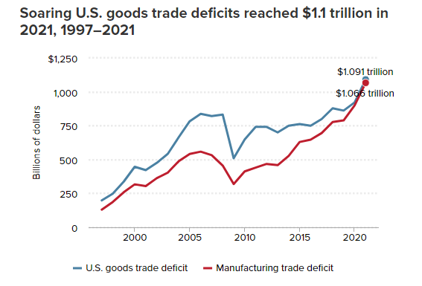

***Figure 12****: Manufacturing deficit in US (Scott 2022)*

***Figure 13****: Unemployment rate and job losses in US (Statista 2024) (Fred 2024)*

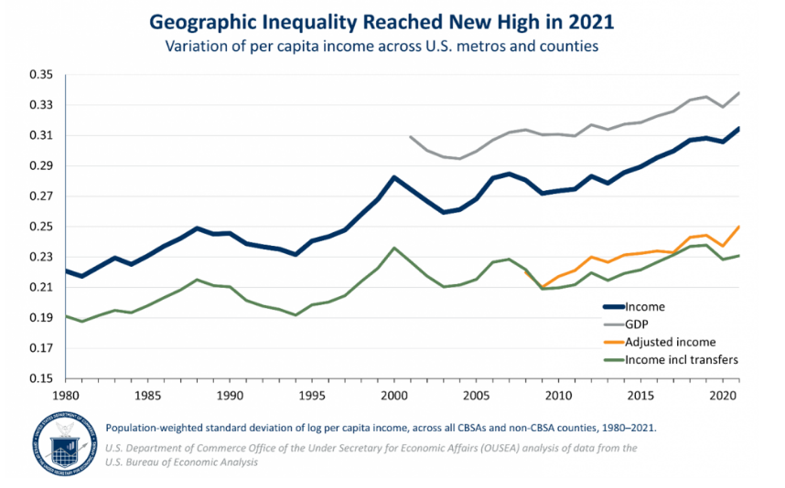

***Figure 14****: Geographic inequality in US (US Department of Commerce 2023)*

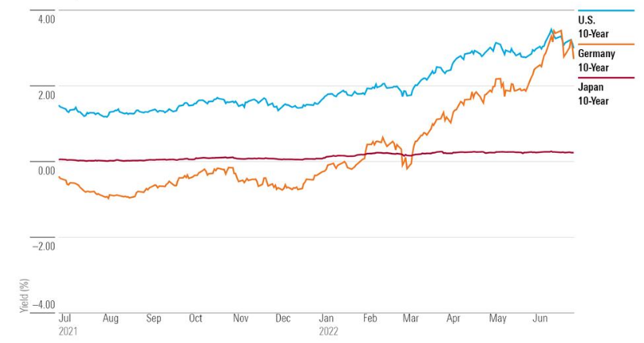

***Figure 15****: Relative government bond yield of US (Ward 2022)*

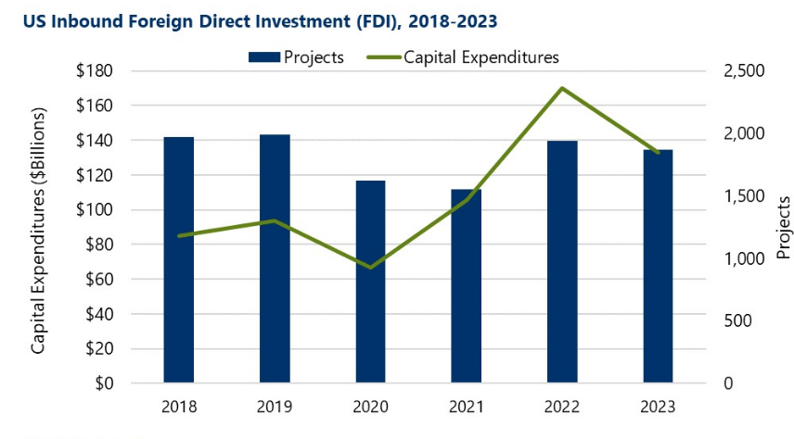

***Figure 16****: US foreign investment and foreign invested project (Hallowell 2024)*

Both USD appreciation and depreciation affect its progress towards SDG achievement. Since 2013, the dollar has increased strongly in value, as discussed, diminishing its export competitiveness in foreign market with hazardous trade deficit. Despite driven strong economics, manufacturing output dropped sharply, causing 226,000 manufacturing job losses in 2019(Scott 2022). Furthermore, UR gradually increased with job losses(Figure 13), challenging for US to achieve SDG-8 with decent work and economic growth. Besides, import-side business benefits with cheap cost signaled inequality, specifically geopraphic inequality rise, concern for SDG-10 achievement regarding reduced-inequality(Figure 14). However, USD value growth attracts investment with secured-return, obviously relatively-high 10-year yield while FDI remains stable with increased projects, boosting economy, facilitating to SDG-8 achievement(Figure 15,16).

Regarding policy, IR-hike policy made USD more expensive; however, helping restraining inflation, and low-income group cover living costs, reducing inequalities in SDG-10 alongside difficulties for businesses with high borrowing costs and debt burdens, hindering economic growth, SDG-8.

# **APPENDIX**

|  |  |
| --- | --- |
| **Variable** | **Sources** |
| **Exchange rate** | Exchange rate of EUR/VND is collected then transform to quarterly starting from Q1/2007 to Q3/2023 from Investing  <https://www.investing.com/currencies/eur-vnd-historical-data> |
| **Inflation rate** | Inflation rate of EUR is collected quarterly by HICP index from Eurostats while that of Vietnam is collected from Trading Economics with transform monthly-to-quarterly.  <https://ec.europa.eu/eurostat/databrowser/view/prc_hicp_manr__custom_12485402/default/table?lang=en> |
| **GDPGR** | GDPGR from Vietnam is collected through Trading Economics quarterly and Euro’s is from OECD  <https://tradingeconomics.com/vietnam/inflation-cpi>  [EUR](https://data-explorer.oecd.org/vis?df%5bds%5d=DisseminateFinalDMZ&df%5bid%5d=DSD_NAMAIN1%40DF_QNA_EXPENDITURE_GROWTH_OECD&df%5bag%5d=OECD.SDD.NAD&dq=Q..EA20..........&pd=2007-Q1%2C2024-Q2&to%5bTIME_PERIOD%5d=false) |
| **Stock price** | Stock price is collected monthly then transformed to quarterly in Investing with VN index and Euro Stoxx 50  <https://vn.investing.com/indices/vn-historical-data>  <https://vn.investing.com/indices/eu-stoxx50-historical-data> |
| **Money supply M2** | Money supply is collected quarterly from ECB data for Euro and combination of Vietstock and Trading Economics for Vietnam  [EUR](https://data.ecb.europa.eu/data/datasets/BSI/BSI.M.U2.Y.V.M20.X.1.U2.2300.Z01.E?chart_props=%3D)  <https://finance.vietstock.vn/du-lieu-vi-mo/51/tin-dung.htm>  <https://tradingeconomics.com/vietnam/money-supply-m2> |
| **Current account balance** | Current account balance is collected quarterly from IFS  <https://data.imf.org/?sk=4c514d48-b6ba-49ed-8ab9-52b0c1a0179b&sid=1390030341854> |
| **Oil price** | Fuel price is collected from Trading Economics  <https://tradingeconomics.com/commodity/crude-oil> |
| **Short-term IR** | EUR’s data is from ECB while Vietnam’s is from Trading Economics  <https://www.ecb.europa.eu/stats/policy_and_exchange_rates/key_ecb_interest_rates/html/index.en.html>  <https://tradingeconomics.com/vietnam/interest-rate> |
| **Long-term IR** | Euro’s long-term rate is collected from FRED while Vietnam IR is from Trading Economics  <https://tradingeconomics.com/vietnam/government-bond-yield>  <https://fred.stlouisfed.org/series/IRLTLT01EZQ156N> |
| **Primary Commodity Price** | Primary commodity price is collected from IMF  <https://www.imf.org/en/Research/commodity-prices> |

*Appendix 1: Independent variables data sources*

*Appendix 2: White test results from R-studio*

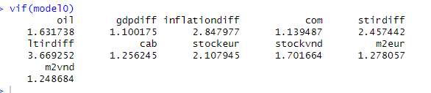

*Appendix 3: VIF test results from R-studio*

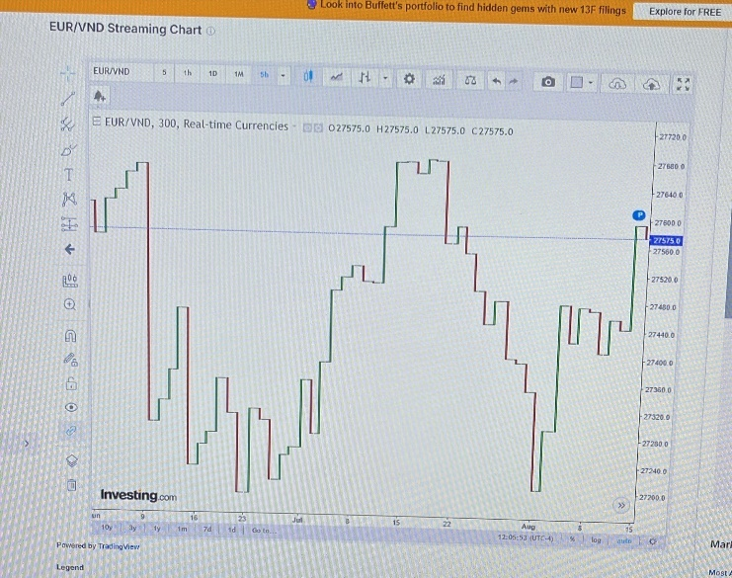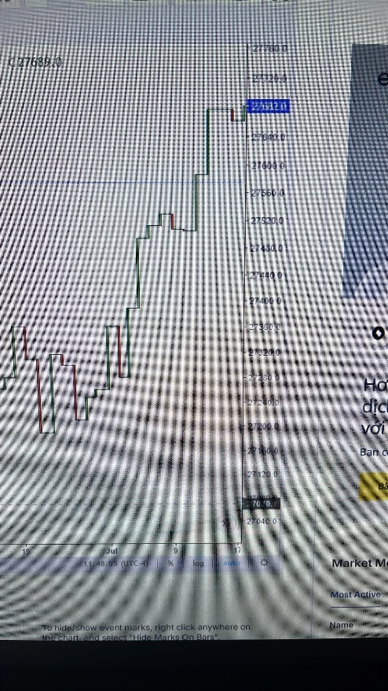

*Appendix 4: Limitation of EUR/VND for candle stick analysis*

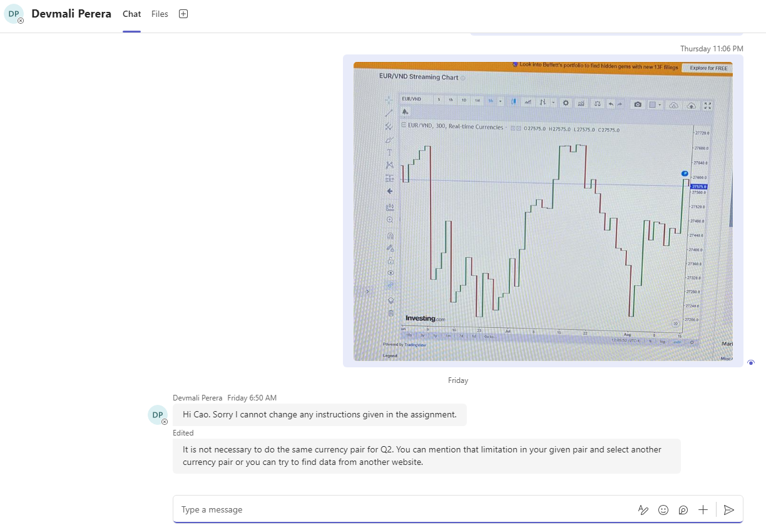

*Appendix 5: Confirmation of EUR/VND limitation and choosing another currency pair for candle stick analysis*

# **REFERENCE**

Adam A and Ofori D (2017) 'Validity of international fisher effect in the West African monetary zone', Journal of Economic Cooperation and Development, 38(3):121-143.

Ali, Mahmood & Bashir 2015, ‘Impact of interest rate, inflation and money supply on exchange rate volatility in Pakistan’, *World Applied Science*.

Antwi S, Issah M, Patience A and Antwi S (2020) ‘The effect of macroeconomic variables on exchange rate: Evidence from Ghana’, Cogent Economics & Finance, 8:1-19, doi:10.1080/23322039.2020.1821483.

Anzuini, A, Cecioni, M & Neri, S 2016, ‘Determinants of the Movements in the Euro-Dollar Exchange Rate During the Sovereign Debt Crisis’, *SSRN Electronic Journal*.

Arghyrou, MG & Chortareas, G 2008, ‘Current Account Imbalances and Real Exchange Rates in the Euro Area*’, *Review of International Economics*, vol. 16, no. 4, pp. 747–764.

Armstrong JS (2001) Principles of Forecasting. A Handbook for Researchers and Practitioners: A Handbook for Researchers and Practitioners, 1 edn, Springer, doi:10.1007/978-0-306-47630- 3, Boston, MA.

Bigalow SW (2011) Profitable candlestick trading: pinpointing market opportunities to maximize profits (Vol. 500). John Wiley & Sons.https://onlinelibrary.wiley.com/doi/book/10.1002/9781119200888

Bogdan, Ž, Cota, B & Erjavec, N 2017, ‘Current Account Balance and Export Performances: Evidence Based on New EU Countries’, *Zagreb International Review of Economics and Business*, vol. 20, no. 2, pp. 33–48.

Bunn DW (1985) 'Statistical efficiency in the linear combination of forecasts', International Journal of Forecasting, 1(2):151-163, doi:https://doi.org/10.1016/0169-2070(85)90020-2. https://www.sciencedirect.com/science/article/pii/0169207085900202

Capra G (2012) Intra-Day Trading Tactics: Pristine. com's Stategies for Seizing Short-Term Opportunities (Vol. 80). John Wiley & Sons

Cavallo, M 2006, *Oil Prices and the U.S. Trade Deficit*, SF Fed, San Francisco Fed, viewed 18 August 2024, <<https://www.frbsf.org/research-and-insights/publications/economic-letter/2006/09/oil-prices-and-the-us-trade-deficit/>>.

Cetin, H 2020, ‘THE IMPACT OF LOCAL INTEREST RATES AND ENDOGENOUS FACTORS ON USD/TL PARITY (1964-2020)’, *Research Gate*, pp. 1–15.

Clemen RT (1989) 'Combining forecasts: A review and annotated bibliography', International Journal of Forecasting, 5(4):559-583.

Clemen RT and Winkler RL (1986) 'Combining Economic Forecasts', Journal of Business & Economic Statistics, 4(1):39-46, doi:10.1080/07350015.1986.10509492. https://www.tandfonline.com/doi/abs/10.1080/07350015.1986.10509492

CRS 2023, ‘Strong Dollar: Implications for U.S. Economy’, *Congressianal Research*, viewed 15 August 2024, <<https://sgp.fas.org/crs/misc/IF12319.pdf>>.

Dang, VC, Le, TL, Nguyen, QK & Tran, DQ 2020, ‘Linkage Between Exchange Rate and Stock Prices: Evidence from Vietnam’, *The Journal of Asian Finance, Economics and Business*, vol. 7, no. 12, pp. 95–107.

Devereux B.M (1997) ‘Real Exchange Rates and Macroeconomics: Evidence and Theory’, The Canadian Journal of Economics, 30(4a):773-808, doi: 10.2307/136269

ECB 2024, ‘We have cut interest rates. Why did we do it and what does that mean for you?’, *www.ecb.europa.eu*.

Edwards S (April 2006) ‘The Relationship Between Exchange Rates and Inflation Targeting Revisited’[conference paper], National Bureau Of Economic Research, Cambridge, accessed 17 August 2024. <https://www.nber.org/papers/w12163>

Fajgelbaum, P, Goldberg, P (Penny), Kennedy, P, Khandelwal, AK & Taglioni, D 2021, ‘The US-China Trade War and Global Reallocations’, *SSRN Electronic Journal*.

FRED 2024, *Unemployment Rate*, Stlouisfed.org, viewed 15 August 2024, <<https://fred.stlouisfed.org/series/UNRATE>>.

Glantz, M, Kissell, R, Mun, J & Paul, K 2014, *Multi-asset risk modeling : techniques for a global economy in an electronic and algorithmic trading era*, Academic Press, San Diego, Amsterdam.

Hallowell, A 2024, *Foreign Direct Investment in the US Remained Strong in 2023*, camoinassociates.com.

Itskhoki, O 2020, ‘THE STORY OF THE REAL EXCHANGE RATE’, *NATIONAL BUREAU OF ECONOMIC RESEARCH*, vol. 13, pp. 1–35.

Jamil MN, Abdul R, Adnan M and Zeeshan M (2023) ‘Cross-cultural study the macro variables and its impact on exchange rate regimes’, Future Business Journal, 9(9):1-15, doi:10.1186/s43093-023- 00189-1.

Keele, L., & Kelly, N. J. (2006). Dynamic models for dynamic theories: The ins and outs of lagged dependent variables. Political analysis, 14(2), 186-205.

Khawaga, A, Esam, M & Hammam, R 2014, ‘EXCHANGE RATES AND INTEREST RATES: AN EMPIRICAL INVESTIGATION OF INTERNATIONAL FISHER EFFECT THEORY THE CASE OF EGYPT (2003-2012) ’, *Economic Forum*, vol. 869.

Koprnická, K 2009, ‘Inflation Differentials in the European Union Empirical Evidence from the New EU Member States ’, *Charles University in Prague*, pp. 1–75.

Lafrance R and Schembri L (2023) Purchasing-Power Parity: Definition, Measurement, and Interpretation, Bank of Canada website, accessed 18 August 2024. https://www.bankofcanada.ca/wp-content/uploads/2010/06/lafrance_e.pdf

Mačerinskienė I and Balciunas A (2015) 'Fundamental exchange rate forecasting models: Advantages and drawbacks', doi: <http://dx.doi.org/10.2139/ssrn.2633138>.

Moore, T & Wang, P 2014, ‘Dynamic linkage between real exchange rates and stock prices: Evidence from developed and emerging Asian markets’, *International Review of Economics & Finance*, vol. 29, pp. 1–11.

Nusair S (2017) 'The J-Curve phenomenon in European transition economies: A nonlinear ARDL approach', International Review of Applied Economics , 31(1):1-27,  
doi:10.1080/02692171.2016.1214109

Pan, M-S, Fok, RC-W & Liu, YA 2007, ‘Dynamic linkages between exchange rates and stock prices: Evidence from East Asian markets’, *International Review of Economics & Finance*, vol. 16, no. 4, pp. 503–520.

Phan, T & Jeong, J 2015, ‘Vietnam Trade Balance and Exchange Rate: Evidence from Panel Data Analysis’, *Applied Economics and Business Research*, vol. 5, no. 4, pp. 220–232.

Rodrik, D 2008, ‘The Real Exchange Rate and Economic Growth’, *Economic Activity*, pp. 365–412.

Schoen, JW 2015, *Why is the dollar rising? What you need to know*, CNBC, viewed 15 August 2024, <<https://www.cnbc.com/2015/01/29/why-is-the-dollar-rising-what-you-need-to-know.html>>.

Scott, R 2022, *U.S. trade deficits hit record highs in 2021: More effective trade, industrial, and currency policies are needed to create more domestic manufacturing jobs*, Economic Policy Institute.

Statista 2024, *Monthly number of job losers in the U.S. January 2022*, Statista, viewed 15 August 2024, <<https://www.statista.com/statistics/217824/seasonally-adjusted-monthly-number-of-job-losers-in-the-in-the-us/>>.

Sumei, L & Guangyou, Z 2016, ‘The Construction of Shanghai Pilot Free Trade Zone and the Interest Rate Liberalization in China’, *Science*, vol. 21, no. 2, pp. 234–246.

Trading Economics 2024, *Brent crude oil | 1970-2020 Data | 2021-2022 Forecast | Price | Quote | Chart*, tradingeconomics.com.

Udagawa Y (2019) ‘Mining stock price changes for profitable trade using candlestick chart patterns’, In Proceedings of the 21st International Conference on Information Integration and Web-based Applications & Services (pp. 118-126).

Umar, M & Dahalan, J 2016, ‘An Application of Asymmetric Toda-Yamamoto Causality on Exchange Rate-Inflation Differentials in Emerging Economies’, *International Journal of Economics and Financial Issues*, vol. 6, EconJournals, no. 2, pp. 420–426.

US Department of Commerce 2023, *Geographic Inequality on the Rise in the U.S.*, U.S. Department of Commerce, viewed 15 August 2024, <<https://www.commerce.gov/news/blog/2023/06/geographic-inequality-rise-us#:~:text=Geographic%20income%20inequality%20has%20risen>>.

Vochozka, M, Rowland, Z, Suler, P & Marousek, J 2020, ‘The Influence of the International Price of Oil on the Value of the EUR/USD Exchange Rate’, *Journal of Competitiveness*, vol. 12, no. 2, pp. 167–190.

Ward, S 2022, *What’s the Impact of the Strong Dollar on My Portfolio?*, Mornign Star, viewed 15 August 2024, <<https://www.morningstar.com/portfolios/whats-impact-strong-dollar-my-portfolio>>.

Witte, W 2007, *The U.S. Economy*, www.ibrc.indiana.edu, Indiana Business Review, Outlook, viewed 15 August 2024, <<https://www.ibrc.indiana.edu/ibr/2006/outlook/national.html#:~:text=To%20begin%20with%2C%20the%20growth>>.